**Phase Field Validation**

To validate the phase field model, we followed <https://www.ems.psu.edu/~chen/publications/JXZhang2008_JAP_Computersimulation.pdf> .

We used the same set of constants. Our grid is 64 by 64 by 32 instead of 128 by 128 by 32.

**(001) Validation**

When the substrate clamping effect is $ε_{11}=ε_{22}=-0.5\%,ε_{12}=0$ BFO should form 71o domain walls (Fig 2a).

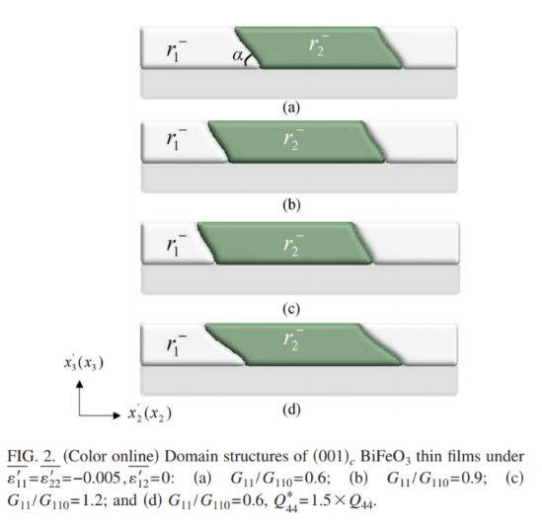

We obtain in correspondence with Fig 2a above:

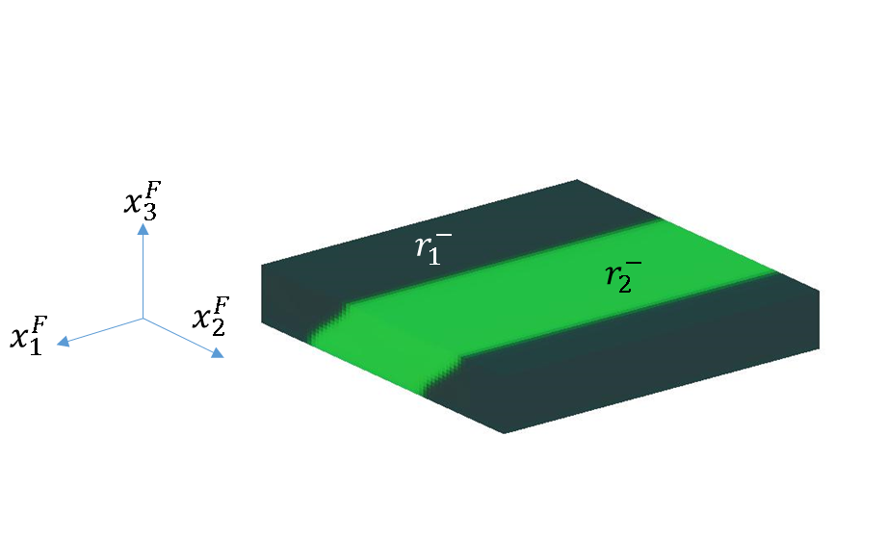

Our (001) Phase Field results for -0.5% strain.

**(101) Validation**

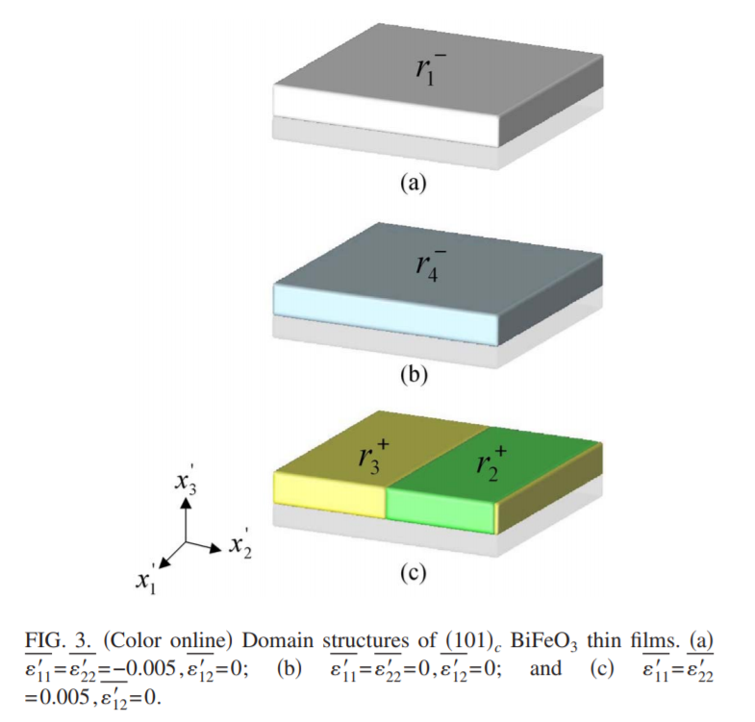

For a BFO thin film grown on a (101) substrate, we obtain in correspondence with Fig 3 above.

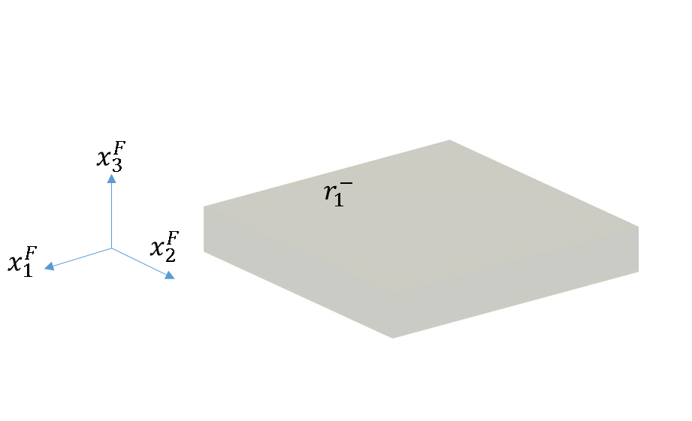

Our Phase Field results for (101) oriented BFO for -0.5% strain

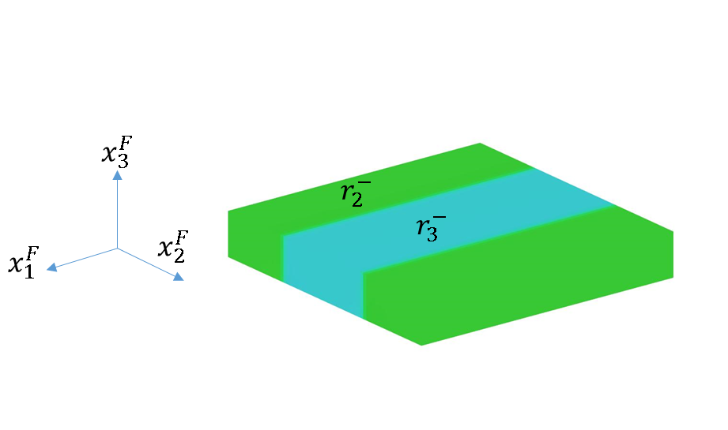

Our Phase Field results for (101) oriented BFO for -0.5% strain. The $r_{2}^{-}/r_{3}^{-}$ is equivalent to $r_{2}^{+}/r_{3}^{+}$.

**(111) Validation**

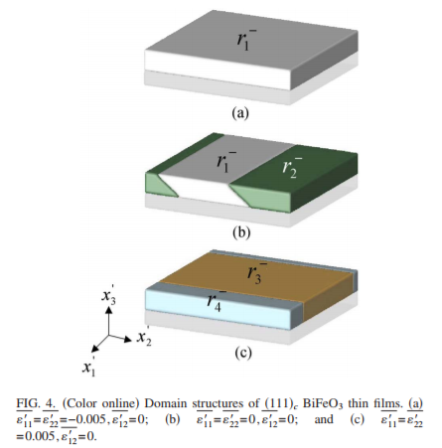

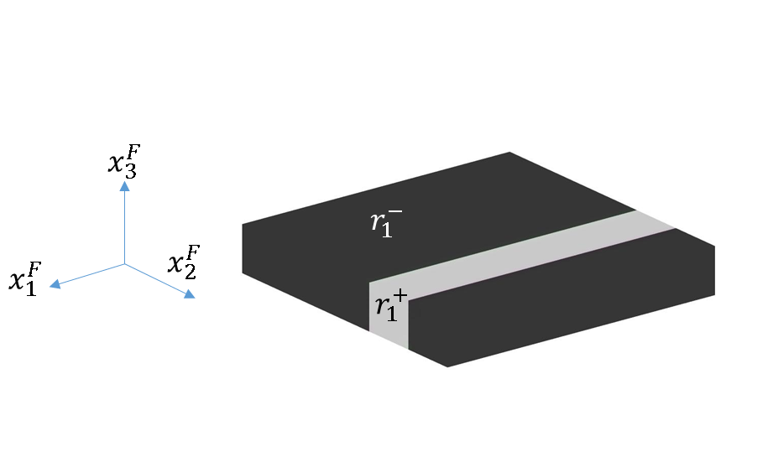

-0.5% substrate strain. $r_{1}^{+}/r_{1}^{-}$ are stable, eventually one should dominate to decrease domain wall energy.

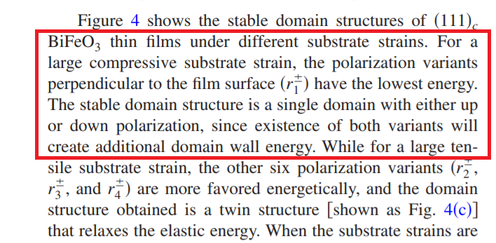

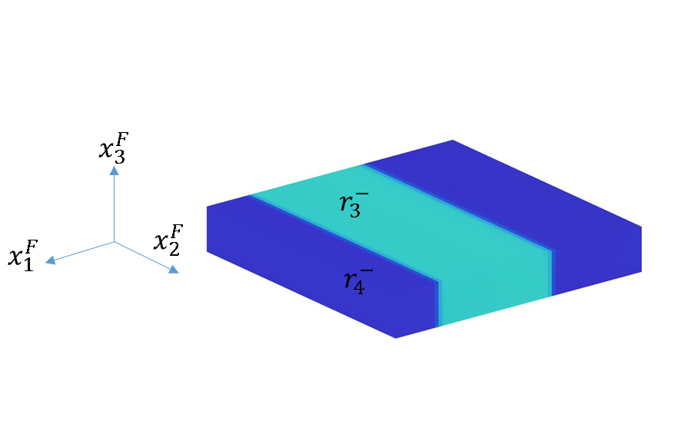

0.5% substrate strain.